

Conditional variable

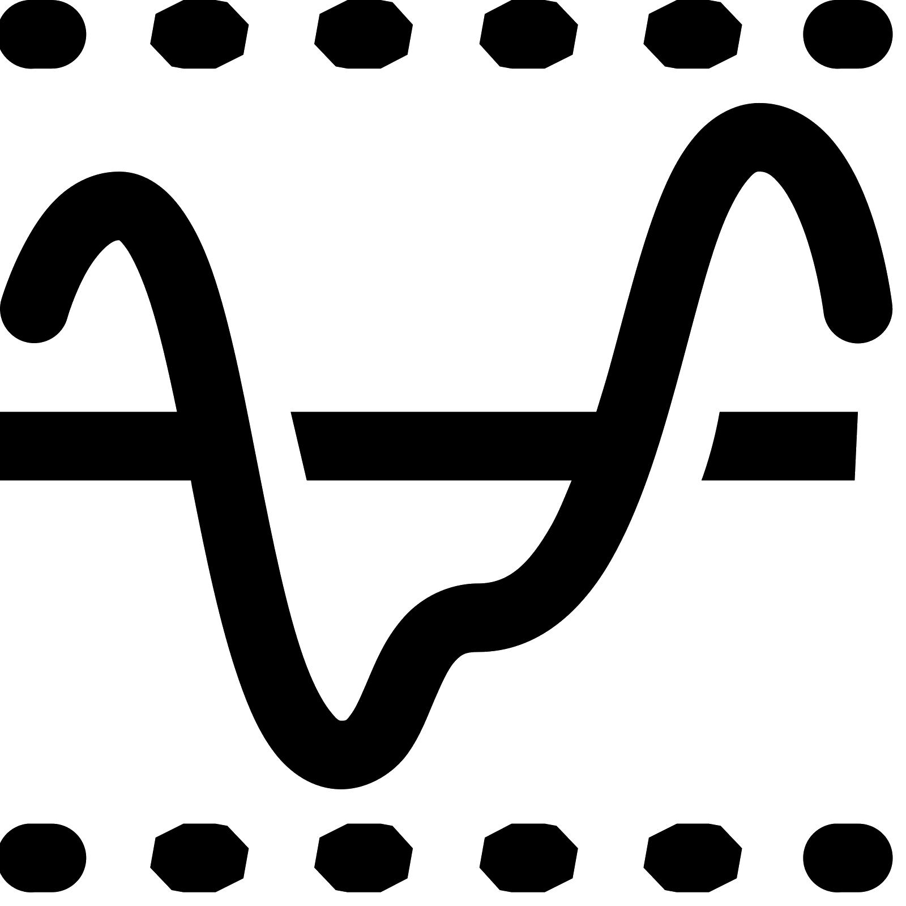

# Introduction

In this document an example dataflow diagram is constructed that monitors the flexion of an elbow and outputs the value of the last time the sample crossed the threshold of 30°.

The diagram created in the example in this document can be downloaded via this [link](https://drive.google.com/file/d/1sHHED3BaZKow_cQpU1YSRTUPnda1u9Sj/view?usp=drive_link).

# Elbow flexion

The first step is to calculate the flexion of the elbow. To do this, we first need to add the Input streams for the “Upper arm” and “Lower arm”.

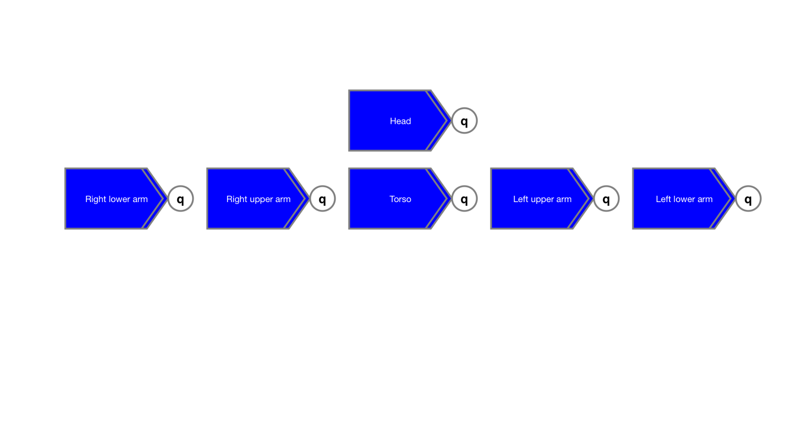

The output of these Input streams are the timestamped orientations of the indicated segment. The *joint angle* between these two segments can now be determined as was described in the document “[Joint angle](https://docs.google.com/document/d/1uUKX8oygqR-JNqFYnPHgXP5zkE3iaiOBvPlRx45IMKs/edit?usp=drive_link)” and as is shown in the sub-diagram in figure 1.

***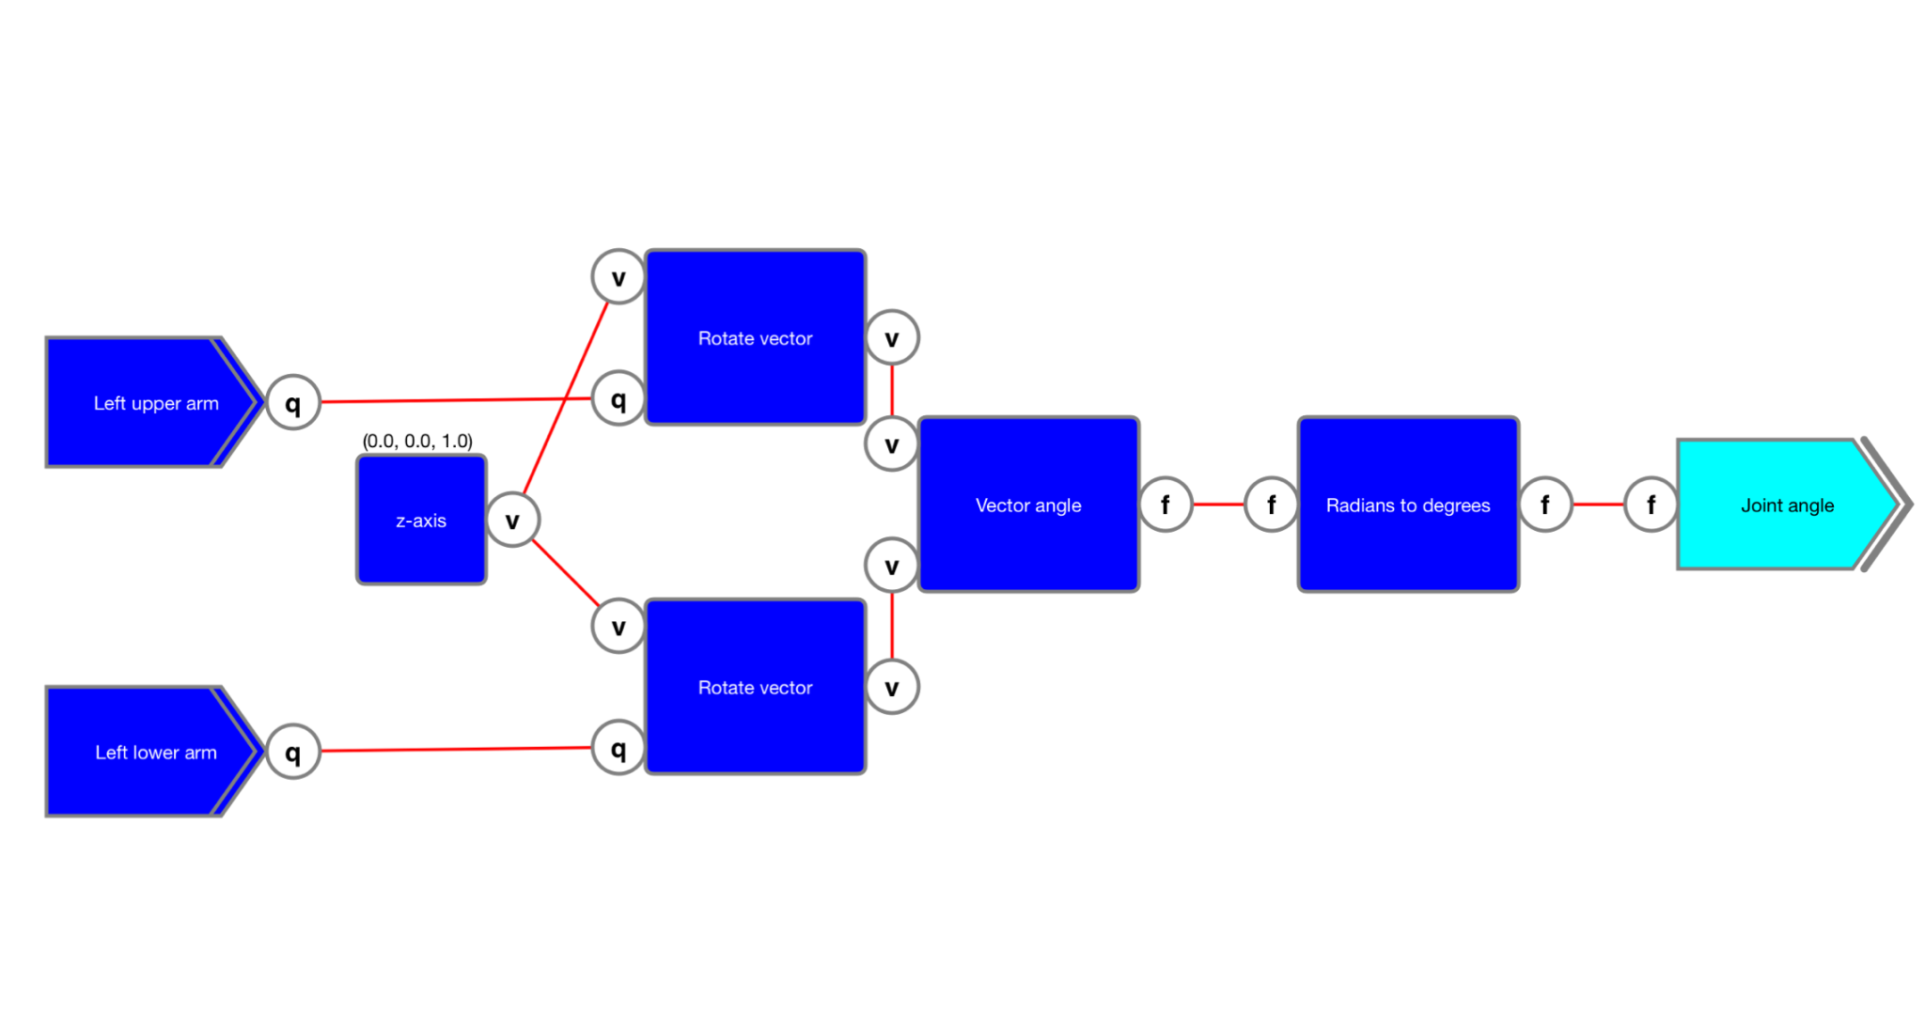******Figure 1******: Joint angle.***

# Threshold detection

With the elbow flexion available as a joint angle in degrees, the next step is to extend the diagram with the functionality to detect when the joint angle becomes larger than 30°.

This is achieved in the sub-diagram in figure 2 where the joint angle is first compared using the "*Larger*" function to a constant holding the threshold of 30°. When this condition is 'true', it must be checked whether the condition was *not* 'true' for the *previous* sample. This is done by buffering the output for one sample. In this way, the output of the “*And*” function is only 'true' when the joint angle *becomes* larger than the threshold.

***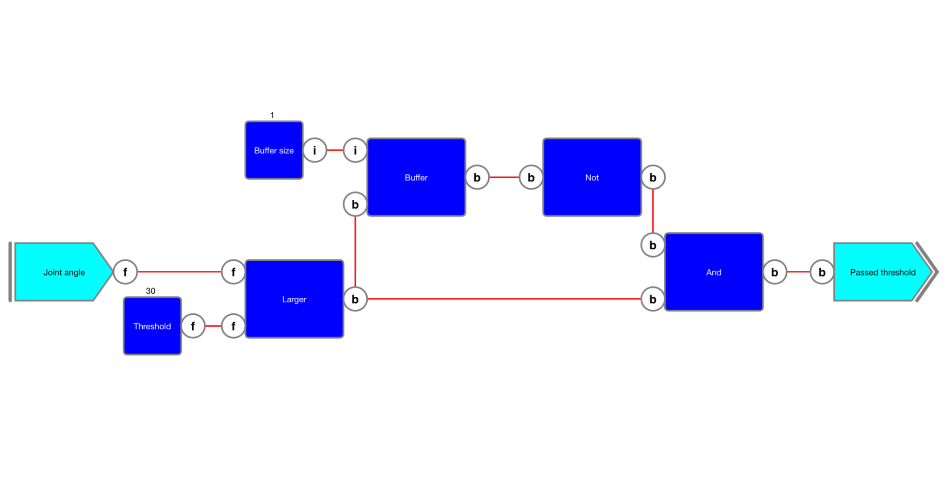******Figure 2******: Threshold detection.***

# Last condition variable

The joint angle must only be updated when the output of the “*Threshold detector*” updates to 'true'. This can be achieved by using a “*Gate*” function as shown in the sub-diagram in figure 3.

***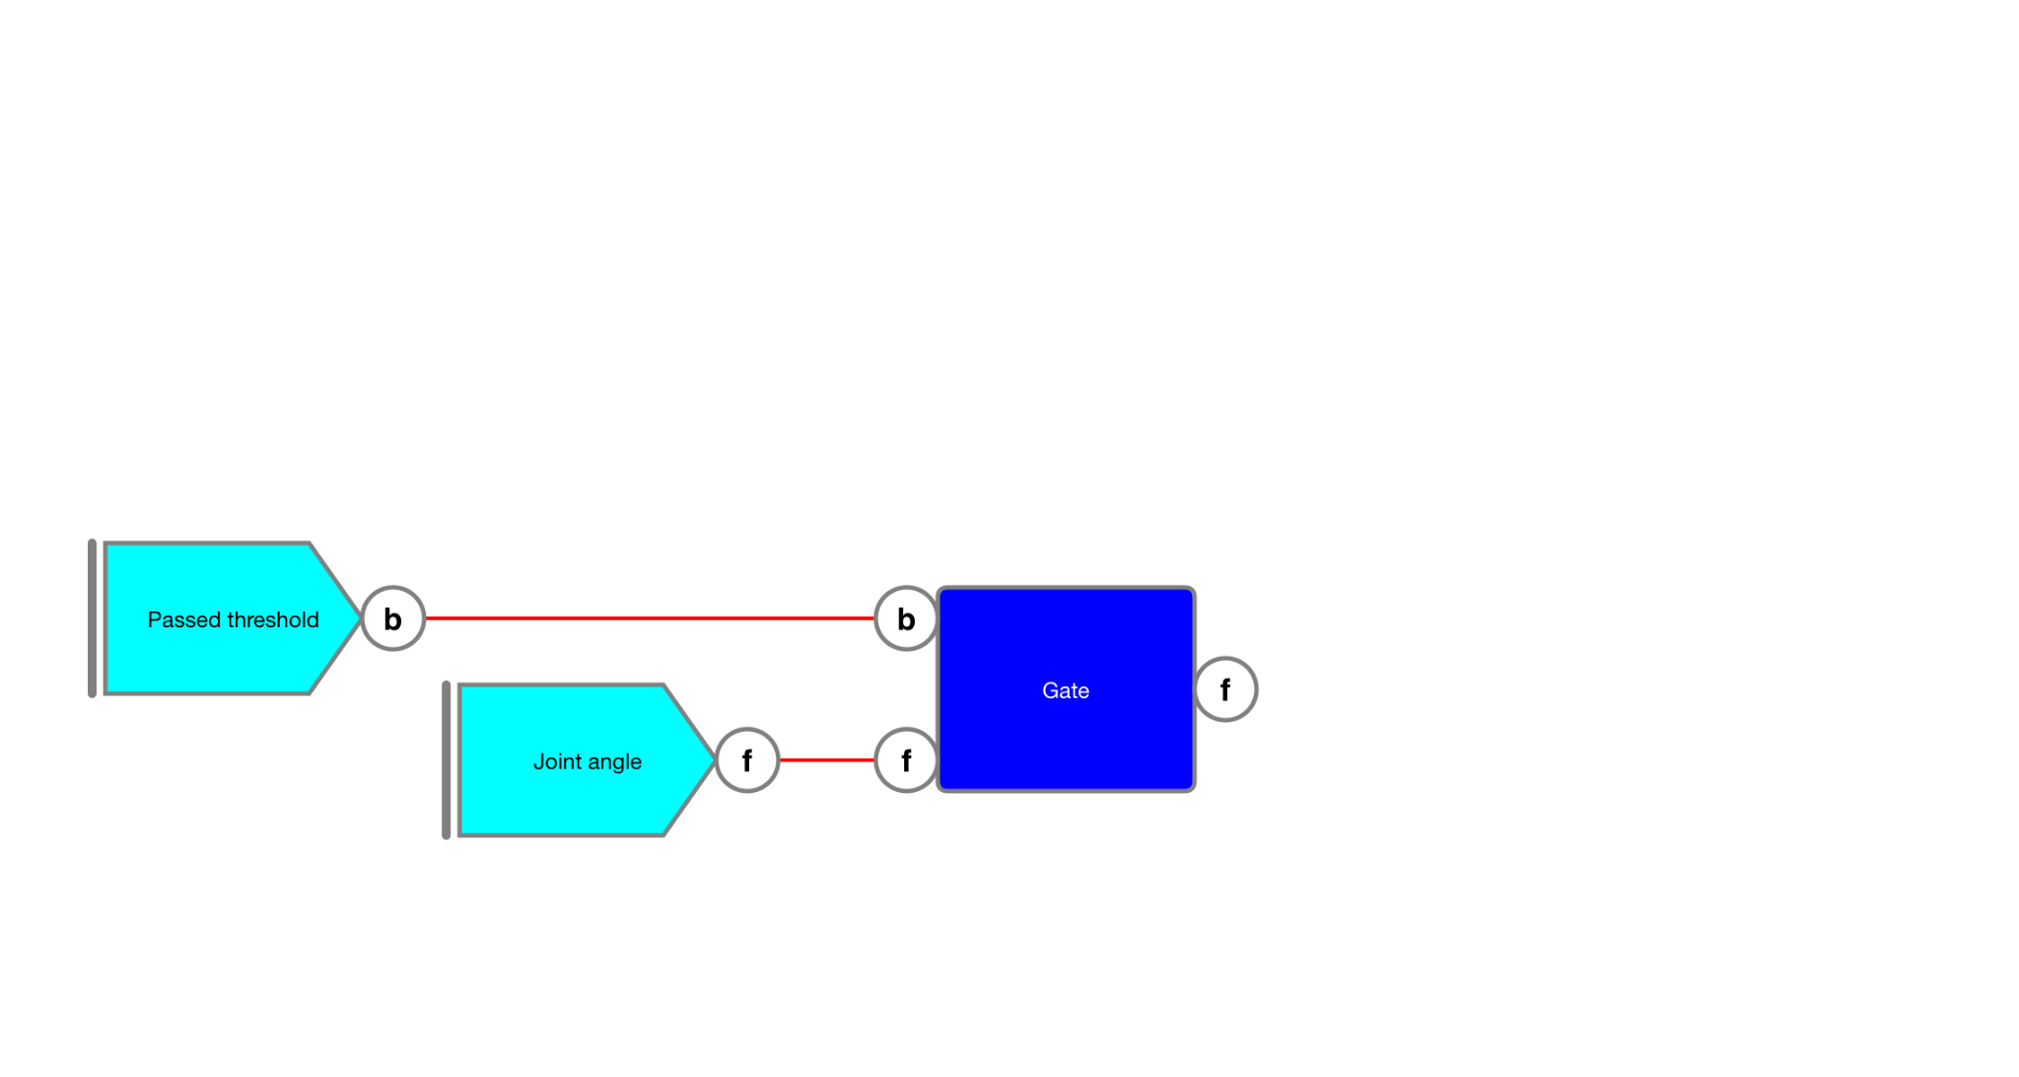******Figure 3******: Gate the value when the threshold is passed.***

The output of the “*Gate*” function will only be updated when the input is updated and when the boolean input is 'true'. This will happen only at the moment the threshold is broken.

Suppose we want to use the value of that update also further on in the diagram, for example as input for a function together with the joint angle. This will not work because the output of the “*Gate*” function will not be updated. Therefore, a “*Trigger*” function is added that will output the value of its input – irrespective whether it was updated or not – when its boolean input is updated to 'true'.

***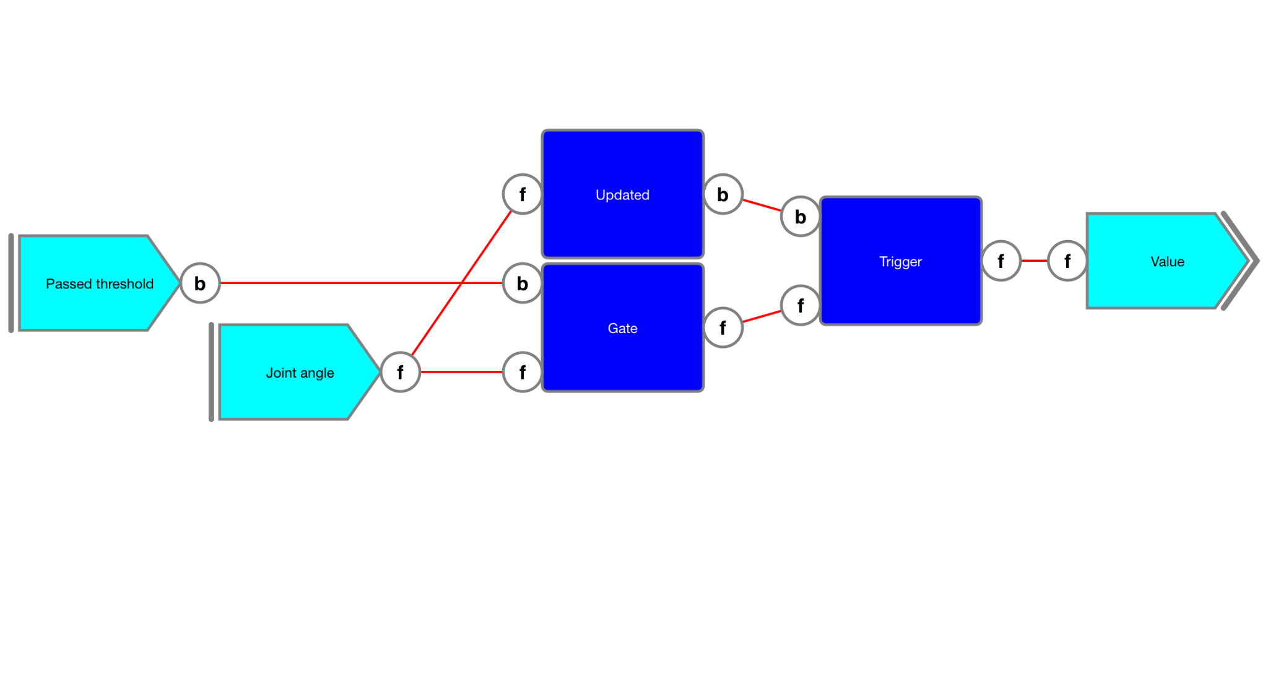******Figure 4******: Capturing the value when the threshold is passed.***

Note that when the “*Gate*” function was never updated, there will be no value at the output yet and the diagram will not generate an output.

# Counter

In the sub-diagram in the previous chapter, the value that is offered at the output is the last time the threshold was broken in the upwards direction. Suppose that we're only interested in the first time this happens. To check this, an "*Update counter*" function is used as shown in the sub-diagram in figure 5.

***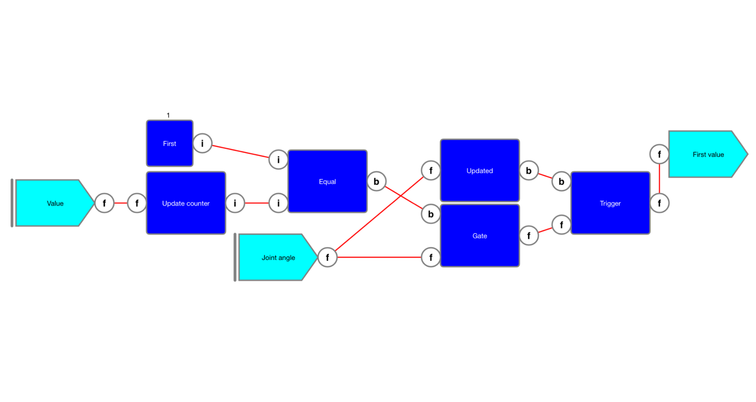******Figure 5******: Capturing the first time the value passed the threshold.***